A Project on

**“STRUCTURAL AUDIT OF OLD BUILDINDS”**

**Submitted to**

**SHIVAJI UNIVERSITY, KOLHAPUR**

In partial fulfillment of the requirement for the award of degree

**BACHELOR OF ENGINEERING IN**

**CIVIL ENGINEERING**

**Submitted By,**

**Mr. SUTAR AKSHAY K. 2018089597**

**Mr. PATIL ROHIT R. 2019022024**

**Mr. PATIL SARVADNYA B. 2019086117**

**Mr. PATIL SUHAS T. 2019087777**

**Mr. GAWADE VITTHAL D. 2019083993**

Under the guidance of

**Prof. Miss. PATIL SWATI**



**DEPARTMENT OF CIVIL ENGINEERING**

**SANT GAJANAN MAHARAJ COLLEGE OF ENGINEERING, MAHAGAON**

**Academic Year 2021-22**

**SANT GAJANAN MAHARAJ COLLEGE OF ENGINEERING, MAHAGAON**

**DEPARTMENT OF CIVIL ENGINEERING**



**CERTIFICATE**

This is to certify that

|  |  |
| --- | --- |
| **Mr. SUTAR AKSHAY K.** | **Mr. PATIL ROHIT R.** |
| **Mr. PATIL SARVADNYA B.** | **Mr. PATIL SUHAS T.** |
| **Mr. GAWADE VITTHAL D.** | |

**of B.E. Civil has successfully carried out the project work on “STRUCTURAL AUDIT OF OLD BUILDING” under my guidance in a satisfactory manner for the partial fulfillment of Bachelor of Technology in Civil Engineering as per the rules and regulations of Shivaji University, Kolhapur. This project work is a record of students own work carried out by him/her under my supervision and guidance during the academic year 2021-22.**

|  |  |
| --- | --- |
| Prof. S. S. PATIL | Prof. A. A. DEWARDE |
| (Project Guide) | (Project coordinator) |
|  |  |
| Prof. S. N. Sanadi | Dr. S. H. Sawant |
| (HOD) | (Principal) |
|  |  |

**ACKNOWLEDGEMENT**

I wish to express my deep, sincere gratitude to my guide **Prof. S. S. PATIL** for his excellent guidance, encouragement, support, and insightful comments throughout the period of my project work. Whatever knowledge and experience I have gained during my study here, I owe it to him.

I would like to extend my deep sense of gratitude to **Prof. S. N. Sanadi**, Head of the Department, SGMCOE, Mahagaon for his support throughout the period of my bachelor’s degree. He has been my pillar of strength during times of downfalls.

I would like to thank our Principal **Dr. S. H. Sawant**, Principal SGMCOE for providing all necessary facilities to complete my project work**.**

My work could have not been completed without the support of my friends, teaching as well as non-teaching staff of the Civil Engineering department.

I am thankful to **Adv. Hon. Annasaheb D. Chavan**, Trustee, SGM Group, Mahagaon, **Hon. Dr. Y. A. Chavan** and **Hon. Dr. S. A. Chavan,** Chairman, SGM Group for giving me the opportunity to carry out my project work.

Finally, I dedicate this work to my parents. My deepest thanks and appreciations are reserved for all my family members and friends**,** whose blessings have been my inspiration to complete this work.

**NAME OF PROJECT GROUP STUDENT**

1. SUTAR AKSHAY K. 2018089597
2. PATIL ROHIT R. 2019088024
3. PATIL SARVADNYA B. 2019086117
4. PATIL SUHAS T. 2019087777
5. GAWADE VITTHAL D. 2019083993

**ABSTRACT**

This project deals to create awareness amongst the civil engineers, residents and owners of building called Structural Audit. The need of structural audit is for maintenance and repairs of existing structures whose life has exceeded the age of 30 years to avoid any mishaps and save valuable human life. The concrete is widely used as construction material being inexpensive, easy for construction, applications and because of it high strength-cost ratio. More than ever, the construction industry is concerned with improving the social, economic and environmental parameters of sustainability. In India, from 1980 onwards the infrastructure industry witnessed stepping up of public investment and growth in infrastructure industry which results in construction of new multistory concrete apartments which are now in the age of thirty plus years. There are many buildings during this period and earlier have reduced strength in due course of time because of structural deficiency, material deterioration, unexpected over loadings or physical damage. If, further use of such deteriorated structure is continued it may endanger the lives of occupants and surrounding habitation. There is demand of appropriate actions and measures for all such building structures to improve its performance and restore the desired functions of structures which may leads to increase its functional life. The periodical structural auditing and diagnosis for health of existing buildings is thus utmost important for finding the present serviceability and structural viability of structures. The structural audit must be carried out following auditing norms, methods of non-destructive testing and code provisions. The structural A.B. Mahadik, B.H Chafekar, Swapnil U Biraris, J. Bhattacharjee & M.H. Jaiswal auditing will help to implement maintenance and repair work timely which leads to prolonged life of the building and safety of the occupants.

**INDEX**

|  |  |  |
| --- | --- | --- |
| **Sr. No.** | **PARTICULARS** | **PAGE NO.** |
| 1 | Introduction |  |
| 2. | Literature Review |  |
| 3. | Methodology |  |
| 4. | Results |  |
| 5. | Conclusion |  |
| 6. | Reference |  |

**List of Pictures**

|  |  |  |
| --- | --- | --- |
| **Sr. No.** | **PARTICULARS** | **PAGE NO.** |
| 1 |  |  |
| 2. |  |  |
| 3. |  |  |
| 4. |  |  |
| 5. |  |  |
| 6. |  |  |

**List of Tables**

|  |  |  |
| --- | --- | --- |
| **Sr. No.** | **PARTICULARS** | **PAGE NO.** |
| 1 |  |  |
| 2. |  |  |
| 3. |  |  |
| 4. |  |  |
| 5. |  |  |
| 6. |  |  |

**INTRODUCTION**

In India there are many old buildings which have reduced strength in due course of time. If further use of such deteriorated structure is continued it may endanger the lives of the occupants and surrounding habitation. Appropriate actions should then be implemented to improve the performance of structures and restore the desired function of structures. Thus, it is utmost important to perform structural audit of existing buildings and to implement maintenance/ repair work timely which will lead to prolonged life of the building and safety of the occupant. To act more responsible and pre-emptive towards the dilapidated buildings, the municipal corporation must issue notices to the buildings and co-operative societies which are more than 30 years old to carry out mandatory structural audit and submit the audit report. Structural audit should highlight and investigate all critical areas and recommend immediate remedial and preventive measures. It should cover the structural analysis of existing frame and find critical elements for all types of loadings. It also helps in delivering a strong building structure with cost effective solutions and appropriate maintenance program. This paper deals with study of different parameter of structural audit including visual inspection, nondestructive testing, core sampling and testing. It also emphasizes on different repairs and retrofitting measures to be used for buildings after structural audit.

**1.1 What is Structural Audit**

Structural Audit is an overall health and performance checkup of a building like a doctor examines a patient. It ensures that the building and its premises are safe and have no risk. It analyses and suggests appropriate repairs and retrofitting measures required for the buildings to perform better in its service life. Structural audit is done by an experienced and licensed structural consultant.

**1.2 Objectives**

* To ensure that structure is safe, risk-free, and habitable.
* To correctly identify parts or sections of a building that may be in need of immediate repair, renovation or replacement.
* To increase life of Buildings.
* For structural audit certificate required by Municipality and other authorities.

**1.3 Need of structural audit of building**

* + For Insurance
  + For Bank Mortgage
  + For Valuation
  + Structure Showing Distress
  + Proposed Additions, Alterations, Extensions in structure
  + For Damage assessment due to earthquake, fire, blast, vibration, corrosion etc

**1.4 Bye-Laws:**

As per clause no. 77 of revised Bye-Laws of Co-operative Housing Societies. The society shall cause the Structural Audit of the building as follows:

1. For building aging between 15 to 30 years once in 5 years.

2. for building aging above 30 years once in 3 years.

**Literature review**

**2.1 A.B. Mahadik et.al.[4] [2014]** This paper deals to create awareness amongst the civil engineers. Residents and of building towards the health examination of existing concrete building called a Structural Audit. The need of structural audit is for maintenance and repairs of existing structures whose life has exceeded the age of 30 years to avoid any mishaps and save valuable human life. The concrete is widely used as construction material being inexpensive, easy for construction, application and because of it high strength-cost ratio. More than ever, the construction industry is concerned with improving the social, economic and environmental parameters of sustainability.

**2.2 B.H Chafekar et. Al, [3] [2013-14]** – Before going in detail about the structural audit is necessary to know about the structure. A structure is a system of inter connected elements to carry loads safety to underground called as Structural Audit. The author shows different methods in paper.

**2.3 Swapnil U Biraris [8] [2017]-** Structural audit is an overall health and performance check-up of buildings. It is important to the building to check their safety and they have no risk. It is process of analyses of building and this process suggest a appropriate repairs and retrofitting measures required for the buildings to perform better in its service life structural audit is an important tool for knowing the real health status of the old buildings.

**2.4 J. Bhattacharjee[7] [2016]**- The construction material mainly reinforced concrete is being used extensively for various types of construction projects. However, the deterioration of Reinforced Concrete Structures is recognized as a major problem worldwide. Apart from requiring regular maintenance, many structure require extensive Repair, Rehabilitation & Retrofitting. Over a period of time, as these structures become older, we find in them certain degradation or deterioration with resultant distress manifested in the form of cracking, splitting, delaminating, corrosion etc. Such deteriorated structures can be rehabilitated and retrofitted by using various types of admixtures and modern repair materials.

**2.5 Sanket.S.Suryavanshi.et al (2018)** The paper gives a complete study on structural repair report carried by author. As per the author, Building was inspected as per each flat internally as well as externally. Defects were observed in columns, slabs, beams, walls and conditions of structural components were return in the sheet. At the same time photographs were taken by the author to collaborate with defects visually. By the investigations surveys they came to know that health condition of building is fair. With the NDT‟s conducted it was concluded that structural members are suffering from class 3 damage. According to CPWD (Central public works department) class 3 damage stands for observation like spalling of concrete cover, structural cracks etc., in which principal repairs are required. So as per observations, Principal repairs were needed to be started as early as possible to avoid further deterioration of the structure. Quality of RCC found was poor as per the result of rebound test and UPV test performed at various locations, so the recommendation was to start repair work which included strengthening of column, plastering works of defected areas and water proofing, etc. Also, rectification of leakage should be in various location of top floors Delay in works could increase the quantity of work due to continuous deterioration the structure

**METHODOLOGY**

**3.1 Proposed Methodology**

1. Selecting an existing building having more than 15 years old to conduct structural audit for our Project.

2. Study of architectural and structural drawings, design criteria, design calculation, etc.

3. If architectural and structural drawings are not available, as build drawings can be prepared.

4. Visual Inspection

* General Information of the building
* Structural system of the building
* Addition or alteration in the building
* Dampness and leakages

5. Conduct Non-destructive and Destructive testing

* Concrete Strength- Rebound hammer, Ultrasonic Pulse velocity test, Core Sampling.
* Chemical Attack- Carbonation test, Chloride Test, Sulphate Test
* Corrosion Potential Assessment- Cover Meter, Half Cell method 6. Post Structural Audit

6. Repairs

Strengthening and retrofitting.

**3.2 Concrete Tests carried out for Project**

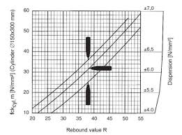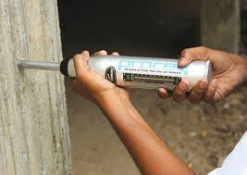1. Rebound Hammer Test **(IS code 13311 Part II)**

Picture No 1. Rebound Hammer Graph No 1. Rebound Number

The rebound hammer test is a non-destructive testing apparatus, whereby the rebound of the spring driven mass is measured after its impact with concrete surface. The output of the rebound hammer is referred to as rebound number and are correlated with surface hardness of concrete.

Procedure

1. The concrete surface is cleaned properly.

2. The hammer is pressed against the concrete surface and released.

3. Six readings are taken and an average is taken.

4. Correlate the average with the compressive strength.

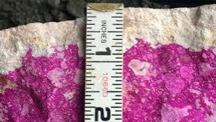2. Carbonation Test

Picture no 2. Carbonation Test Picture no 3. Phenolphthalein Indicator

A Spray of 0.2% solution of phenophthalein chemical is done on the surface of the concrete to find the area affected by the carbonation. Phenolphthalein solution indicates the change of pH level in the concrete. If the concrete changes its grey colour to pink, it means that the concrete is in good condition.

Procedure

1. Identify test location & drill a hole in the concrete to reach the reinforcement.

2. Inject chemical & Insert steel rod.

3. The color change determines till what depth carbonation has taken place. Carbonation tests can also be done on extracted cores by applying the chemical on the core and measuring the depth till which the carbonation has taken place.

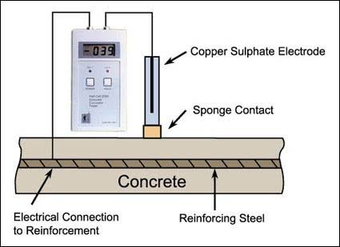3. Half Cell potentiometer Test / Corrosion Test

Picture No 4. Corrosion Meter

The half-cell potential test is the only corrosion monitoring technique standardized in ASTM C876-15: Standard Test Method for Corrosion Potentials of uncoated reinforcing steel in concrete. It is used to determine the probability of corrosion within the rebar in reinforced concrete structure.

Procedure

1. Identify test location & drill a hole in the concrete to reach the reinforcement.

2. Establish electric contact with the reinforcement.

3. Place the half cell at various locations on the concrete surface & measure voltage. In the voltmeter.

4. Correlate the obtained voltages to probability of corrosion as per ASTM standard.

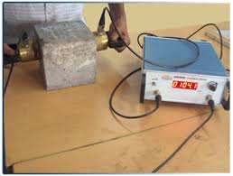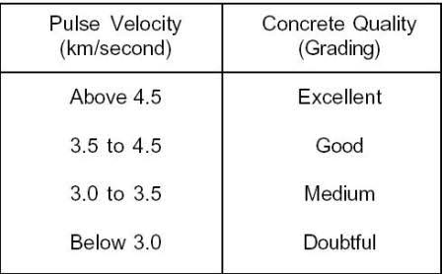4. Ultrasonic Pulse Velocity Test/ UPV test (IS code 13311 Part I)

Picture no. 5 UPV meter Picture no. Table no 1

This test is conducted by passing a pulse of ultrasonic through concrete to be tested and measuring the time taken by pulse to get through the structure. Higher velocities indicate good quality and continuity of the material, while slower velocities may indicate concrete with many cracks or voids.

Procedure:

1. The concrete surface where probes are to be applied is cleaned properly.

2. Grease is applied on the test surfaces.

3. The probes are pressed on the surface of the structural element to remove air gaps.

4. Distance between the two probes is: noted.

5. Read time taken for the ultrasonic pulse from the instrument.

6. Calculate Velocity = distance / time.

1. Core extraction test **(IS: 1199 and IS: 516)**

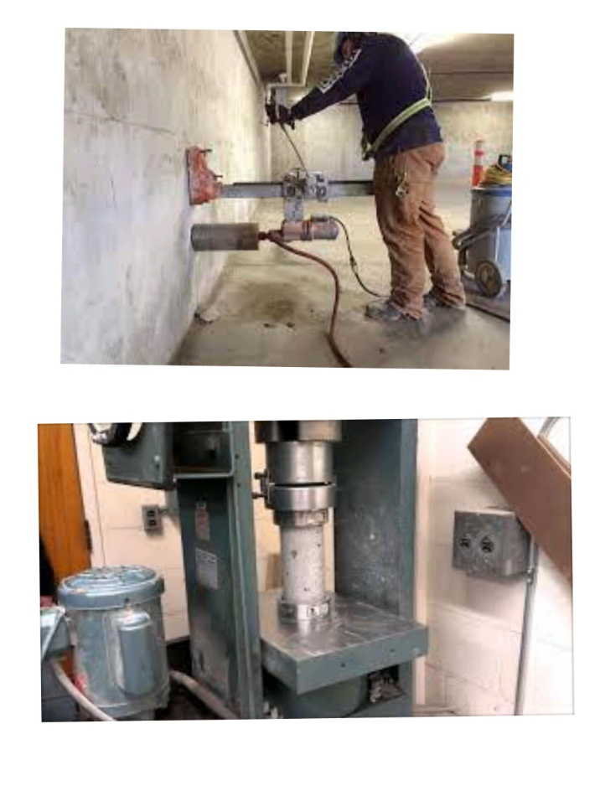This test is used to determine the compressive strength of a concrete core, which has usually been extracted from an existing structure. The value of compressive strength can then be used in conjunction with other measured properties to assess the condition of the concrete.

Picture No 6. Core test

Procedure:

1. The exact position from where the core can be extracted from the concrete member is determined using a rebar mapping device so as to avoid the reinforcing bars within the concrete member.

2. Concrete core of diameter of at least three times the maximum nominal size of coarse aggregate to obtained using 2 core cutting machine.

3. The obtained cores are capped on both sides in the laboratory using epoxy mortar. The capped surfaces shall be at right angles to the axis of the specimen and shall not depart from a plane by more than 0.05 mm.

4. The core fs then placed in water at a temperature of 24° to 30°C for 48 hours before testing. 5. The core is then subjected to compression forces on a compression testing machine. The breaking point is observed & noted.

6. The obtained compressive strength is converted to equivalent cube strength and is reported after applying suitable correction factors. In accordance with the Indian standards.

**Structural Audit Report**

1. Basic Information

Name of Building: Sangam Collection, (Mr. Vijay Bansali)

Type of Structure: RCC Building of G+2 floor

Address: Wada Road, Bazarpeth, Rajgurunagar, PUNE

Age: 26 Years

Weather Effect: Yes

2. Structural Drawing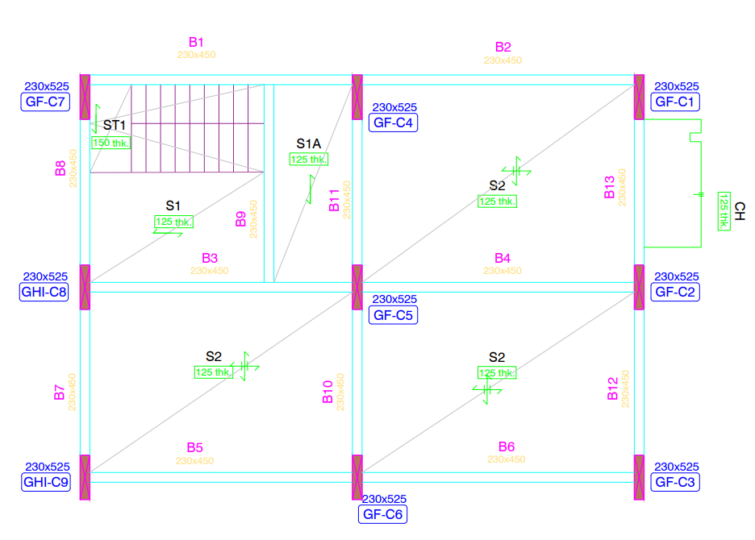

3. Visual Inspection.

|  |  |  |
| --- | --- | --- |
| Sr. No. | Description | Remark |
| 1 | Foundation Strata | Hard strata observed on 1.70 m. and soft strata seen on 1.50 m. depth as per information by Client |
|  | Visual Inspection | Minor hair cracks are visible on external wall specially on corner of walls. |
|  | Settlement of columns | Not properly identified on site |
|  | Cracks in column, wall, joints at plinth | Minor vertical cracks are developed on columns and minor cracks are seen on joint of slab, beam, columns |
| 2 | Superstructure inspection |  |
|  | Cracks in columns/rusting of steel/ exposed steel | Rusted, broken reinforcement is visible below underneath portion of slab. |
|  | Cracks in beam/ rusting of steel/ exposed steel | Minor vertical cracks are seen on wall surface whereas long wall and short wall are joint together. |
|  | Cracks in slab/ rusting of steel/ exposed steel | Rusted, Broken reinforcement is visible below underneath portion of slab |
|  | Cracks in external walls | Minor vertical and inclined cracks are developed |
|  | Cracks in internal walls | Minor vertical and inclined cracks are developed |
| 3 | Leakages and dampness in external walls | Not seen |
| 4 | Terrace waterproof and inspection | Seepage is notices on underneath portion of slab. |
| 5 | Inspection of water tank above the terrace | Not seen any Leakages |
| 6 | Building last repair details | Before 5 years |
| 7 | RCC or load bearing | RCC type structure |
| 8 | Test recommended |  |
|  | Rebound Hammer | 10 readings minimum |
|  | UPV | 10 readings minimum |
|  | Carbonation | 5 readings minimum |
|  | Corrosion | 5 readings minimum |
|  | Core Extraction | 5 readings minimum |

Building was inspected by us as per Shops externally. Columns, beams, slabs, walls, and also some areas defects occurred, where observed, and conditions of the structural components were recorded on sheet. At the same time, we have taken photographs elaborate the defects visually.

4. NDT Observations:

Under NDT we have perform rebound hammer test, UPV test, and carbonation test to check performance of the structural components like beams, slabs, columns, internal and external walls.

i) Core Extraction Test

|  |  |  |  |  |  |  |  |  |  |
| --- | --- | --- | --- | --- | --- | --- | --- | --- | --- |
| Sr. No. | ID marks | Dia. mm | Length mm | Weight kg | Crushing load kN | Compressive strength N/mm² | Correction for Dia. | Compre. Strength corrected for L/D | Equivalent cube comp strength N/mm² |
|  | Ground floor |  |  |  |  |  |  |  |  |
| 1 | C-1 | 68 | 130 | 1.15 | 43.02 | 11.84 | 12.55 | 12.43 | 15.54 |
| 2 | C-2 | 68 | 133 | 1.17 | 51.40 | 14.15 | 15.00 | 14.92 | 18.65 |
| 3 | C-3 | 68 | 124 | 1.14 | 28.74 | 7.91 | 8.39 | 8.22 | 10.28 |
| 4 | C-4 | 68 | 127 | 1.17 | 69.13 | 19.03 | 20.17 | 19.88 | 24.84 |
| 5 | C-5 | 68 | 102 | 0.95 | 40.74 | 11.21 | 11.89 | 11.23 | 14.04 |
| 6 | C-6 | 68 | 119 | 1.07 | 39.66 | 10.92 | 11.57 | 11.25 | 14.07 |
| 7 | C-7 | 68 | 124 | 1.10 | 48.84 | 13.44 | 14.25 | 13.97 | 17.44 |
| 8 | C-8 | 68 | 127 | 1.14 | 34.09 | 9.38 | 9.95 | 9.80 | 12.25 |
| 9 | C-9 | 68 | 102 | 1.01 | 48.64 | 13.39 | 14.19 | 13.41 | 16.76 |
|  |  |  |  |  |  |  |  |  |  |
|  | First floor |  |  |  |  |  |  |  |  |
| 10 | C-1 | 68 | 104 | 0.95 | 33.77 | 9.29 | 9.85 | 9.34 | 11.68 |
| 11 | C-2 | 68 | 116 | 1.06 | 37.36 | 10.28 | 10.90 | 10.55 | 13.18 |
| 12 | C-3 | 68 | 118 | 1.08 | 39.54 | 10.88 | 11.54 | 11.20 | 14.00 |
| 13 | C-4 | 68 | 110 | 1.02 | 29.91 | 8.23 | 8.73 | 8.36 | 10.45 |
| 14 | C-5 | 68 | 107 | 0.98 | 37.97 | 10.45 | 11.08 | 10.56 | 13.20 |
| 15 | C-6 | 68 | 130 | 1.16 | 31.08 | 8.55 | 9.07 | 8.98 | 11.22 |
| 16 | C-7 | 68 | 112 | 1.02 | 23.16 | 6.37 | 6.76 | 6.49 | 8.12 |
| 17 | C-8 | 68 | 95 | 0.85 | 18.36 | 5.05 | 5.36 | 5.00 | 6.25 |
| 18 | C-9 | 68 | 112 | 1.04 | 38.35 | 10.56 | 11.19 | 10.75 | 13.44 |
|  | Second floor |  |  |  |  |  |  |  |  |
| 19 | C-1 | 68 | 120 | 1.03 | 18.40 | 5.06 | 5.37 | 5.23 | 6.54 |
| 20 | C-2 | 68 | 94 | 0.82 | 35.10 | 9.66 | 10.24 | 9.54 | 11.93 |
| 21 | C-3 | 68 | 104 | 0.88 | 19.60 | 5.39 | 5.72 | 5.42 | 6.78 |
| 22 | C-4 | 68 | 130 | 1.16 | 18.81 | 5.18 | 5.49 | 5.43 | 6.79 |
| 23 | C-5 | 68 | 127 | 1.14 | 21.80 | 6.00 | 6.36 | 6.27 | 7.83 |
| 24 | C-6 | 68 | 111 | 1.01 | 26.01 | 7.16 | 7.59 | 7.28 | 9.10 |
| 25 | C-7 | 68 | 103 | 0.92 | 27.28 | 7.51 | 7.96 | 7.53 | 9.42 |
| 26 | C-8 | 68 | 112 | 0.98 | 14.04 | 3.86 | 4.10 | 3.94 | 4.92 |
| 27 | C-9 | 68 | 130 | 1.16 | 17.78 | 4.89 | 5.19 | 5.14 | 6.42 |
|  |  |  |  |  |  |  |  |  |  |

|  |  |  |  |
| --- | --- | --- | --- |
|  | Average Rebound |  |  |
| Column No. | Ground floor | First Floor | Second floor |
| C-1 | 31.8 | 30.2 | 23.6 |
| C-2 | 34.5 | 29.8 | 30.2 |
| C-3 | 28.5 | 31.2 | 25.3 |
| C-4 | 34 | 26 | 26.1 |
| C-5 | 34 | 31.1 | 22.4 |
| C-6 | 36 | 24.2 | 23.6 |
| C-7 | 34.3 | 24.6 | 25.5 |
| C-8 | 30.4 | 25.1 | 22.5 |
| C-9 | 36.2 | 28 | 23.1 |
| B-2 | 40.1 | 41.5 | 40.5 |
| B-5 | 38.9 | 40.7 | 40.2 |
| B-6 | 42.2 | 41.0 | 40.0 |
| B-12 | 42.0 | 42.6 | 41.8 |

ii) Rebound Hammer Report

iii) UPV Test Report

|  |  |  |  |  |  |  |
| --- | --- | --- | --- | --- | --- | --- |
| SR. NO. | Meas. Type | Result | Name | No. of Meas. | Time 1 (µs) | Velocity (m/s) |
|  |  |  |  |  |  |  |
| 1 | Pulse Velocity | 3497 m/s | GF-C1-T-001 | 1 | 171.6 | 3497 |
| Pulse Velocity | 3077 m/s | GF-C1-B-001 | 1 | 195 | 3077 |
|  |  |  |  |  |  |  |
| 2 | Pulse Velocity | 3202 m/s | GF-C2-B-001 | 1 | 187.4 | 3202 |
| Pulse Velocity | 3125 m/s | GF-C2-T-001 | 1 | 192 | 3125 |
|  |  |  |  |  |  |  |
| 3 | Pulse Velocity | 760 m/s | GF-C4-T-001 | 1 | 789.8 | 760 |
|  |  |  |  |  |  |  |
| 4 | Pulse Velocity | 3536 m/s | GF-C5-T-001 | 1 | 169.7 | 3536 |
|  |  |  |  |  |  |  |
| 5 | Pulse Velocity | 3494 m/s | GF-C6-T-002 | 1 | 166 | 3494 |
| Pulse Velocity | 3161 m/s | GF-C6-B-001 | 1 | 183.5 | 3161 |
|  |  |  |  |  |  |  |
| 6 | Pulse Velocity | 4335 m/s | GF-C7-T-001 | 1 | 69.2 | 4335 |
| Pulse Velocity | 4478 m/s | GF-C7-B-001 | 1 | 67 | 4478 |
|  |  |  |  |  |  |  |
| 7 | Pulse Velocity | 3226 m/s | GF-C8-B-001 | 1 | 124 | 3226 |
| Pulse Velocity | 3396 m/s | GF-C8-T-002 | 1 | 117.8 | 3396 |
|  |  |  |  |  |  |  |
| 8 | Pulse Velocity | 4172 m/s | FF-C1-T-001 | 1 | 71.9 | 4172 |
|  |  |  |  |  |  |  |
| 9 | Pulse Velocity | 3697 m/s | FF-C2-T-001 | 1 | 108.2 | 3697 |
| Pulse Velocity | 3540 m/s | FF-C2-B-001 | 1 | 113 | 3540 |
|  |  |  |  |  |  |  |
| 10 | Pulse Velocity | 3378 m/s | FF-C3-M-001 | 1 | 177.6 | 3378 |
|  |  |  |  |  |  |  |
| 11 | Pulse Velocity | 3521 m/s | FF-C4-M-001 | 1 | 170.4 | 3521 |
|  |  |  |  |  |  |  |
| 12 | Pulse Velocity | 3173 m/s | FF-C6-M-001 | 1 | 189.1 | 3173 |
|  |  |  |  |  |  |  |
| 13 | Pulse Velocity | 3300 m/s | 2F-C9-T-001 | 1 | 151.5 | 3300 |
| Pulse Velocity | 3272 m/s | 2F-C9-T-002 | 1 | 152.8 | 3272 |
|  |  |  |  |  |  |  |
| 14 | Pulse Velocity | 3628 m/s | 2F-C8-T-001 | 1 | 137.8 | 3628 |
| Pulse Velocity | 3579 m/s | 2F-C8-T-002 | 1 | 139.7 | 3579 |
|  |  |  |  |  |  |  |
| 15 | Pulse Velocity | 3234 m/s | 2F-C6-T-001 | 1 | 154.6 | 3234 |
| Pulse Velocity | 3127 m/s | 2F-C6-B-001 | 1 | 159.9 | 3127 |
|  |  |  |  |  |  |  |
| 16 | Pulse Velocity | 3027 m/s | 2F-C2-T-001 | 1 | 165.2 | 3027 |
|  |  |  |  |  |  |  |
| 17 | Pulse Velocity | 3057 m/s | 2F-C1-T-001 | 1 | 196.3 | 3057 |
| Pulse Velocity | 3365 m/s | 2F-C1-B-001 | 1 | 178.3 | 3365 |
|  |  |  |  |  |  |  |
| 18 | Pulse Velocity | 3492 m/s | 2F-C7-T-001 | 1 | 171.8 | 3492 |
| Pulse Velocity | 3513 m/s | 2F-C7-T-002 | 1 | 170.8 | 3513 |
|  |  |  |  |  |  |  |
| 19 | Pulse Velocity | 3532 m/s | 2F-C3-T-001 | 1 | 169.9 | 3532 |
| Pulse Velocity | 3405 m/s | 2F-C3-B-001 | 1 | 176.2 | 3405 |
|  |  |  |  |  |  |  |
| 20 | Pulse Velocity | 4186 m/s | 2F-C4-T-001 | 1 | 143.3 | 4186 |
| Pulse Velocity | 2892 m/s | 2F-C4-B-001 | 1 | 207.5 | 2892 |

iv) Carbonation Test

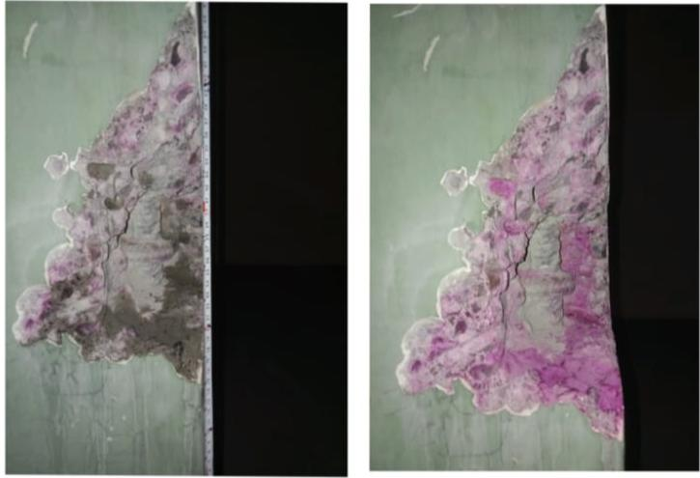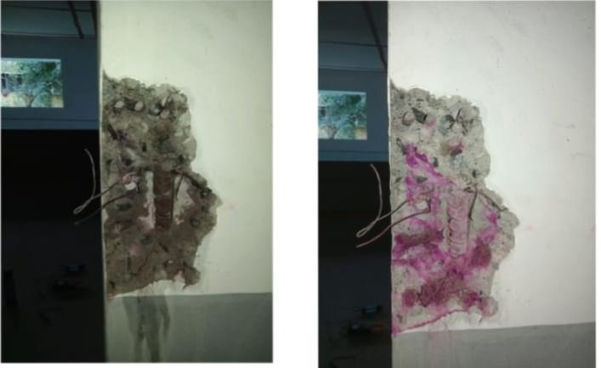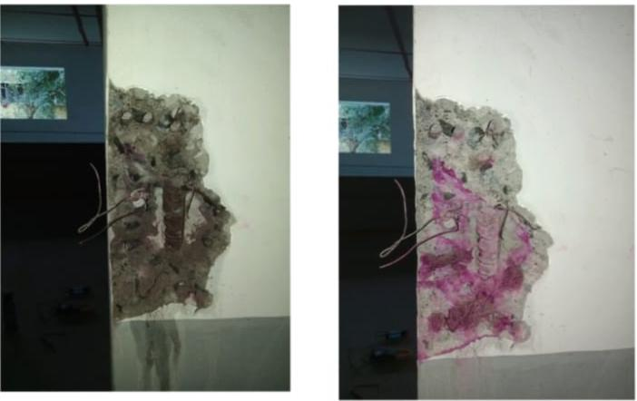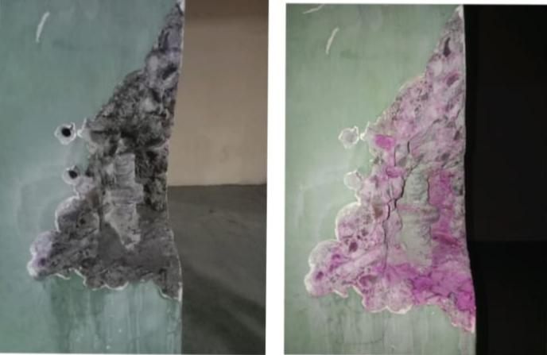Picture no 7 Picture no. 8

Picture no 9 Picture no 10

**PROPOSAL FOR STRENGTHENING OF COLUMNS**

1. BACKGROUND

Some of the columns in the project head developed poor strength compared to the design grade of concrete. This was confirmed by non-destructive test. It was proposed to strengthen the column to match the capacity as per design grade of concrete. (M15)

This was referred to study the data and design a suitable strengthening for enhancing the capacity of the column to match the design grade all the required data was send by consultant.

This report presents the design mythology adopted, strengthening scheme along with the load capacities of the column after strengthening.

1. DETAILS OF COLUMNS

The structure is basically G+2 building the structure was built some time ago and it is informed that the concrete grade was M15 the cross section and Steel in the column where provided the details show in the table.

|  |  |  |  |  |
| --- | --- | --- | --- | --- |
| Col. No. | Floor | C/S mm X mm | Reinforcement (Area) | Concrete Strength  NDT (N/mm²) |
|  | Ground | 230 X 525 | 4-16 Dia. + 2-12 Dia. (1030 mm²) | 16.54 |
| C1 | First | 230 X 525 | 4-16 Dia. + 2-12 Dia. (1030 mm²) | 11.68 |
|  | Second | 230 X 525 | 4-16 Dia. + 2-12 Dia. (1030 mm²) | 6.54 |
|  |  |  |  |  |
|  | Ground | 230 X 525 | 4-16 Dia. + 2-12 Dia. (1030 mm²) | 18.65 |
| C2 | First | 230 X 525 | 4-16 Dia. + 2-12 Dia. (1030 mm²) | 13.18 |
|  | Second | 230 X 525 | 4-16 Dia. + 2-12 Dia. (1030 mm²) | 11.93 |
|  |  |  |  |  |
|  | Ground | 230 X 525 | 4-16 Dia. + 2-12 Dia. (1030 mm²) | 10.28 |
| C3 | First | 230 X 525 | 4-16 Dia. + 2-12 Dia. (1030 mm²) | 14 |
|  | Second | 230 X 525 | 4-16 Dia. + 2-12 Dia. (1030 mm²) | 6.78 |
|  |  |  |  |  |
|  | Ground | 230 X 525 | 4-16 Dia. + 2-12 Dia. (1030 mm²) | 24.84 |
| C4 | First | 230 X 525 | 4-16 Dia. + 2-12 Dia. (1030 mm²) | 10.45 |
|  | Second | 230 X 525 | 4-16 Dia. + 2-12 Dia. (1030 mm²) | 6.79 |
|  |  |  |  |  |
|  | Ground | 230 X 525 | 4-16 Dia. + 2-12 Dia. (1030 mm²) | 14.04 |
| C5 | First | 230 X 525 | 4-16 Dia. + 2-12 Dia. (1030 mm²) | 13.2 |
|  | Second | 230 X 525 | 4-16 Dia. + 2-12 Dia. (1030 mm²) | 7.83 |
|  |  |  |  |  |
|  | Ground | 230 X 525 | 4-16 Dia. + 2-12 Dia. (1030 mm²) | 14.07 |
| C6 | First | 230 X 525 | 4-16 Dia. + 2-12 Dia. (1030 mm²) | 11.22 |
|  | Second | 230 X 525 | 4-16 Dia. + 2-12 Dia. (1030 mm²) | 9.1 |
|  |  |  |  |  |
|  | Ground | 230 X 525 | 4-16 Dia. + 2-12 Dia. (1030 mm²) | 17.47 |
| C7 | First | 230 X 525 | 4-16 Dia. + 2-12 Dia. (1030 mm²) | 8.12 |
|  | Second | 230 X 525 | 4-16 Dia. + 2-12 Dia. (1030 mm²) | 9.42 |
|  |  |  |  |  |
|  | Ground | 230 X 525 | 4-16 Dia. + 2-12 Dia. (1030 mm²) | 12.25 |
| C8 | First | 230 X 525 | 4-16 Dia. + 2-12 Dia. (1030 mm²) | 6.25 |
|  | Second | 230 X 525 | 4-16 Dia. + 2-12 Dia. (1030 mm²) | 4.92 |
|  |  |  |  |  |
|  | Ground | 230 X 525 | 4-16 Dia. + 2-12 Dia. (1030 mm²) | 16.76 |
| C9 | First | 230 X 525 | 4-16 Dia. + 2-12 Dia. (1030 mm²) | 13.44 |
|  | Second | 230 X 525 | 4-16 Dia. + 2-12 Dia. (1030 mm²) | 6.42 |

1. Grouping of Columns

Simplicity and is of working the columns have been grouped best on the compressive strength and strengthening has been carried out considering the lowest value of compressive strength in the group the grouping of colony shown in the below

|  |  |  |
| --- | --- | --- |
| GROUP | COMPRESSIVE STRENGTH RANGE (N/mm²) | COLUMN (FLOOR) IN GROUP |
|  |  |  |
| I | 5-9 | C1 (SF), C3 (SF), C5 (SF), C7(FF) |
|  |  |  |
| II | 9-11 | C3 (GF), C4 (FF), C6 (SF), C7 (SF) |
|  |  |  |
| III | 11-14 | C1(FF), C2(FF,SF), C5(FF), C9 (FF) |
|  |  |  |
| IV | >14 | C1(GF), C2 (GF), C3 (FF), C4 (GF), C5 (GF), C6 (GF), C7 (GF), C9 (GF) |
|  |  |  |
| V |  | C8 COLUMN |
|  |  |  |

1. LOAD CARRYING CAPACITY OF COLUMNS

The different loads on columns at different floors have been provided but the actual load carrying capacities have been calculated as per the NDT results. The actual load carrying capacity, Pu Act has been obtained by considering the lowest value of compressive strength in the group and the required load capacity the required lower carrying capacity has been opted by considering the grade of concrete as M20 as currently and M20 is the minimum structural grade the load capacities are shown in the table.

|  |  |  |  |  |
| --- | --- | --- | --- | --- |
| COLUMN GROUP | COLUMN IN GROUP | FCK N/mm² | Pu Act kN | Pu Req kN |
|  |  |  |  |  |
| I | C1 (SF), C3 (SF), C5 (SF), C7(FF), C9 (SF) | 6.25 | 644 | 1303 |
|  |  |  |  |  |
| II | C3 (GF), C4 (FF), C6 (SF), C7 (SF) | 10.28 | 837 | 1303 |
|  |  |  |  |  |
| III | C1(FF), C2(FF,SF), C5(FF), C9 (FF) | 11.22 | 882 | 1303 |
|  |  |  |  |  |
| IV | C1(GF), C2 (GF), C3 (FF), C4 (GF), C5 (GF), C6 (GF), C7 (GF), C9 (GF) | 14 | 1015 | 1303 |
|  |  |  |  |  |
|  | C8 (GF) | 12.25 | 932 | 1303 |
| V | C8 (FF) | 6.25 | 644 | 1303 |
|  | C8 (SF) | 4.92 | 581 | 1303 |

1. STRENGTHENING OPTIONS

The different strengthening options like micro concrete encasement, steel plate funding micro concrete is ideal method of strengthening for enhancing the capacities you 100% and also for columns with inherent strengths lower than 10N/mm².

Fibre wrapping is the quickest and the most visible 1 in most of the cases here also the fibre wrapping has been considered for columns Fck values above 9N/mm² because for lower strength columns to many wraps are required carbon fibre wrapping advantages.

* Does not increase the section of the column.
* Quick and less time consuming
* No need of curing
* No maintenance required
* Not laborious
* Safe operation
* Does not add dead load to the structure.
* Latest and most advanced technique of strengthening
* Adequate safety factors built in the design.

Show the carbon fibre wrapping is recommended for the most column except where it is not visible in which case micro concreting is suggested.

1. DESIGN PROCEDURE

* The columns strengthen with micro concrete had screen design using the equation and guidelines of our IS code of practice IS 456-2000
* The columns were wrapping is used are different using the guidelines and the metallurgy provided in ACI 440-2R

**SAMPLE CALCULATIONS**

Calculate axial load carrying capacity of column

For C1 (SF), C3 (SF), C5 (SF), C7(FF), C9 (SF)

Size of rectangular column = 230 mm x 525 mm

Grade of concrete = M20

Fck = Characteristics of compressive strength of concrete = 6.25 N/mm2

Grade of steel = Fe500

fy = yield strength or ultimate tensile strength of steel = 500 N/mm2

Number of steel bar = 4+2 nos

Diameter of steel bar = 16mm & 12mm

Axial load carrying capacity of column formula

**PuAct= 0.4FckAct.Ac + 0.67fy. Asc. (As per IS456 2000)**

Where Pu= Ultimate axial load carrying capacity of column

Fck = characteristics of compressive strength of concrete (as per NDT)

Ac = area of concrete in column which will be calculated

Asc = area of steel in column which will be calculated

So we have to following find the value

1. Ac =? Area of concrete
2. Asc =? Area of steel
3. Pu =? Axial load carrying capacity

Soln :

1. First, we have calculated gross cross-sectional area of column

Ag = gross cross-sectional area of column

Size of column = 230 x 525 mm2

Ag = 120750 mm2

1. We have to calculate area of steel in column

Asc = Area of steel in Columns

No. and Dia. of steel bar = 4-16 Dia. + 2-12 Dia.

Area of bar = (4 x π/4 x D2) + (4 x π/4 x d2)

Where π = 3.14, D = 16mm, d = 12mm

Asc = (4 x π/4 x 162) + (2 x π/4 x 122)

Asc = 1030.44 mm2

1. Now we calculate area of concrete in column

Ac = area of concrete

We know that the gross cross-sectional area is equal to area of concrete in column and area of steel in column.

**Ag = Ac + Asc**

**Ac = Ag - Asc**

Putting the value of gross sectional area of column is equal to area of concrete in column and area of steel in column

Ac = 120750-1030 mm2

Ac = 119720 mm2

Putting all the value in formulafor ultimate axial load carrying capacity of column

**PuAct= 0.4FckAct.Ac + 0.67fy. Asc.**

where, Fck = 6.25 N/mm2

Ac = 119720 mm2

fy = 500 N/mm2

Asc = 1030 mm2

Pu = (0.4 x 6.25 x 119720) N + (0.67 x 500 x 1030) N

Pu = 299300N + 345050N

Pu = 644350N

Converting into Kilo Newton we have to divide by 1000

Pu = 644350N/1000 = 644.35 kN

For columns C3 (GF), C4 (FF), C6 (SF), C7 (SF)

Pu = 837 kN

For columns C1(FF), C2(FF,SF), C5(FF), C9 (FF)

Pu = 882 kN

For columns C1(GF), C2 (GF), C3 (FF), C4 (GF), C5 (GF), C6 (GF), C7 (GF), C9 (GF)

Pu = 1015 kN

STRENGTHENING SCHEME

As per ultimate axial load the difference columns shall be strength as per the guidelines of the above mention reference documents and the strengthening mythology is indicated in the table below

|  |  |  |
| --- | --- | --- |
| Group | Columns | Strengthening Scheme |
|  |  |  |
| I | C1 (SF), C3 (SF), C5(SF), C7(FF), C9 (SF) | Provide 50mm thick micro concrete encasement using 66MUCIS and rainforced with 50 x50 MM and 2.35 mm wailed mesh all around the columns l shaped share connector 60 x 60 MM and 8 mm tire shall be provided one share connector shall be provided on all the sides at vertical spacing of 500 MM C/C and staggered |
|  |  |  |
| II | C3 (GF), C4 (FF), C6 (SF), C7 (SF) | Provided 3 wraps of 400 GSM carbon fibre rap the overlap shall be 100 mm |
|  |  |  |
| III | C1(FF), C2(FF,SF), C5(FF), C9 (FF) | Provided to wraps of 400 GSM carbon fibre rap the overlap shall be 100 mm |
|  |  |  |
| IV | C1(GF), C2 (GF), C3 (FF), C4 (GF), C5 (GF), C6 (GF), C7 (GF), C9 (GF) | Provided one rap of 400 GSM GSM carbon fiber wrap and the overlap shall be 100 mm |
|  |  |  |
| V | C8 (GF,FF,SF) | Provide 50mm thick micro concrete encasement using 66MUCIS and reinforced with 50 x50 MM and 2.35 mm wailed mesh all around the columns l shaped share connector 60 x 60 MM and 8 mm tire shall be provided one share connector shall be provided on all the sides at vertical spacing of 500 MM C/C and staggered |

**FUTURE SCOPE**

By structural audit of structure its life span and strength can be calculated. This is the initial stage of structural audit of building. Non-Destructive Tests is necessary. By these test results the strength of different components can be calculated.

**CONCLUSION**

The structural diagnosis is vast, important and highly responsible job which is connected with the lives of human beings. It is mandatory and advisable to carry out the periodical structural audit of the buildings by professional experts and act immediately through recommendations provided in audit report. The defects of structural members are due to combined effects of carbonation, corrosion and effect of continuous drying and wetting.

1. Useful for insurance claims.

2. Helps to understand exact nature of distress before undertaking the structural repairs.

3. Useful for loan application to bank, useful for insurance claim.

4. Additional proof of sound structure before purchase or sale flat.

5. Members can understand the exact status condition of their individual flat.

6. Easier to convince, to get co-operation and fund from members.

7. To produce if required by registrar or BMC or any other Govt. Dept.

8. Even members can visualize the extent of repairs during work and can experience.

9. Helps contractors to understand the exact nature of distress before touching the structure for repairs, so chances of increasing the work/cost is minimum

**REFERENCES**

1) A.B. Mahadik et.al.[4] [2014]

2) B.H Chafekar et. Al, [3] [2013-14]

3) Swapnil U Biraris [8] [2017]-

4) J. Bhattacharjee [7] [2016]

5) Sanket.S.Suryavanshi.et al (2018)

6) Indian Standard: 1331:1992 (Part I) NDT method of Test- Ultrasonic Pulse Velocity.

7) Indian Standard 13311:1992 (Part II) NDT method of Test- Rebound Hammer

8) ACI 546R-04- Concrete repair guide

9) ACI 542-12- Code Requirement for elevation, Repair and Rehabilitation of concrete buildings.

10) Indian Standard: 456:2000 Plain and Reinforced concrete

11) Indian Standard 516:1959 Method of test for strength of concrete

**WEBSITES**

* [www.structwel.com](http://www.structwel.com)
* [www.cpwd.com](http://www.cpwd.com)
* [www.wikipedia.org](http://www.wikipedia.org)